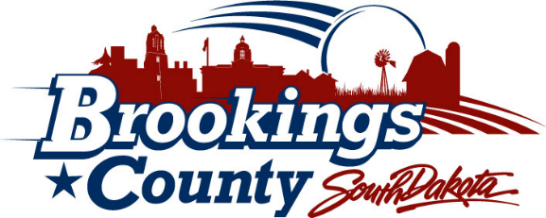
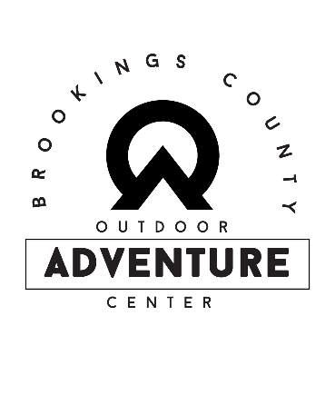

Brookings County Outdoor Adventure Center Advisory Board Meeting
Monday, January 26th, 2026 – 12:00 PM
Brookings County Outdoor Adventure Center
2810 22nd Ave. S., Brookings, SD

- Call to Order, 12:00 PM, Monday, January 26th, 2026
- Invitation for a citizen to schedule time on the BCOAC Advisory Board agenda for an item not listed.
Anyone wanting to speak during this agenda item must sign in prior to the start of the meeting. Any requested action items must be scheduled for a future meeting date.
- Determination of a quorum
Five board members must be present for a quorum
- Approval of Agenda
Action: Motion to approve, Comments, Voice Vote
- Approval of Minutes – December 1st, 2026.
Action: Motion to approve, Comments, Voice Vote
- Approval of Financial Report
Action: Motion to approve, Comments, Voice Vote
- Reports
  - Director’s Report
  - 4-H Youth Advisor’s Report
- Regular Business
- Other Business
  - Items for the next agenda
- Adjournment
Action: Motion to approve, Voice Vote
Next Meeting: Monday, March 16th at Noon.

